Recruitment of Museum Volunteers to guide at National Museum Singapore (NMS)

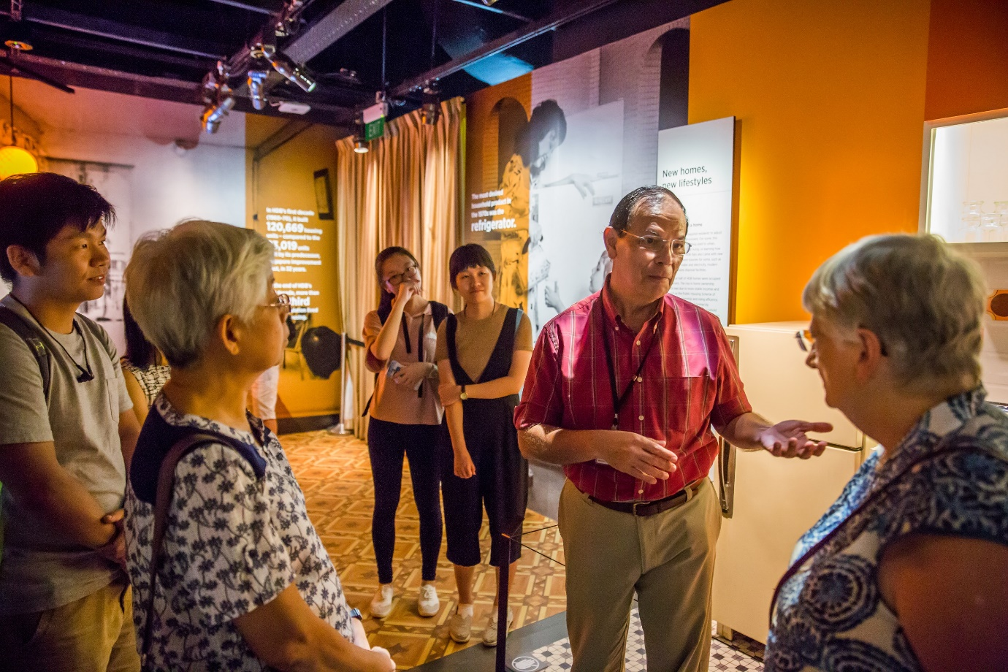
Museum Volunteers (MVs) are recruiting English guides to guide on weekends and public holidays at the National Museum Singapore (NMS). If you have a thirst for continuous learning, enjoy meeting people and sharing your passion in the history, art and culture in Singapore, we want you!
If you are selected to be a guide at NMS, you will be required to commit to guiding 24 tours over 2 years. Tours include NMS History Gallery tours, Special exhibition tours, Community tours and any special request. An amount of $150 will be collected from shortlisted candidates to defray the cost of the training.
Please come and find out more about our upcoming recruitment during our information sharing session on 29 June 2019, 10:30 am to 11:30 am. Venue: National Museum Singapore, Basement 1 Gallery Theatre. 93 Stamford Road, Singapore 178897
The Recruitment Process:
- Attend the information session on 29 June 2019. Please register your attendance : https://forms.gle/tRjQGMmYPS61Rjty9

- Check the training schedule and confirm you can commit to the training and the guiding requirements

- Submit your application here https://form.gov.sg/5ce79a3bdbdf5f0017e30084. Clarifications can be emailed to: museumvolsingapore@gmail.com. Applications close on 05 July 2019

- Check your email to see if you have been shortlisted for an interview. The interviews will be held on 27 July 2019 and 03 August 2019

- Visit NMS to take a photo of one of your favorite artefact. If you are shortlisted for an interview, you will be required to bring this photo (on your phone/tablet or digital camera) and you would have to describe this artefact to us.

- Check your email to see if you have been selected to be a trainee

Training Details:
Training is conducted by both Museum Volunteers and curators / experienced speakers and is scheduled from 7 Sept 2019 to 9 Nov 2019 for NMS. A 5 minute and 10 minute tour presentation is scheduled at certain milestones to prepare you for the 1 hour tour and assessment. Details of the training are as follows:
Dates | Activity / Topics
7 September 2019  14 September 2019  21 September 2019  28 September 2019  5 October 2019  12 October 2019  19 October 2019  02 November 2019  **9 November 2019 | National Museum of Singapore (NMS)  Building and Architecture  Ancient Singapore: Temasek to Singapura 1299 – 1819  Colonial Singapore: 1819 – 1942  Personalities of our historical past  Syonan-To WW2: 1942  Colonial and A Nation in the Making, National Identity  Singapore: post-1965  Goh Seng Choo Gallery, Level 2 Living galleries  MV Training committee to assess the 5 minutes, 10 minutes and 1 hour tour by trainees
07 December 2019 | Graduation
Dec 2019 onwards | Start actual NMS tour
** Assessment dates
About Museum Volunteers
The Museum Volunteers (MV) group started on 1 May 2004 and has about 200 members. MV provides free tours in English to the public on weekends and public holidays at the National Museum of Singapore (NMS), Asian Civilizations Museum (ACM), The Peranakan Museum (TPM), Singapore Art Museum (SAM), Sun Yat Sen Nanyang Memorial Hall (SYSNMH), Malay Heritage Centre (MHC) and Indian Heritage Centre (IHC). We just celebrated our 15th Anniversary this year.

