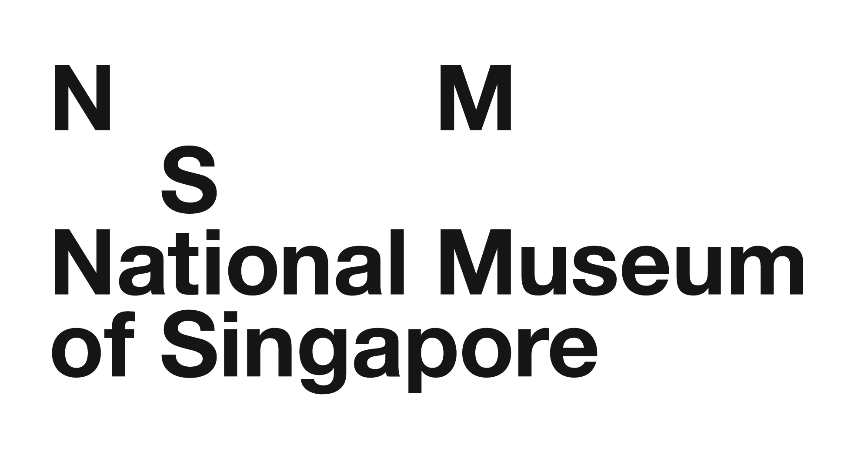
Attention: Education Department
Tel: 6332 3957 Fax: 6332 3587
Email: nhb_nm_schools@nhb.gov.sg

Booking Form

School : _________________________________________________________________________________________________

School’s Sub BU Code (applicable for e-invoice process): ________________________________________________________________

Contact Person : ___________________________________________ Email : __________________________________________

Contact No. : __________________ (HP) _________________ (O) Fax No. : __________________________________________

Mailing Address : _________________________________________________________________________________________________

Title of School Workshop | Date | Time | Level | No. of Students | No. of Adults
1.
2.
3.
4.

*Admission to NMS permanent galleries is free for students who are Singaporeans / PRs and accompanying teacher with MOE passes.

Do any of your students require special attention, if yes please tick any of the following below:

ADHD Autistic Disorder Learning Disabilities Down Syndrome Emotional Disturbance

Health Concerns: _________________________________ (Please specify.) Others: _________________________________ (Please specify.)

Please read through the following Terms & Conditions before endorsing this booking form with your signature and school stamp on the next page.

TERMS & CONDITIONS

- Waiver of Liability
Students must be accompanied by teachers at all times (recommended ratio of 2 teachers to 40 students), during the entire duration of the programme/workshop.
The National Museum of Singapore shall not be responsible or liable in any way for any loss, injury, mishap (including personal injury) of any students and/or teachers.

- Cancellation / No-show
  - Fees will not be refunded for any school booking cancelled less than 30 days prior to the commencement of the programme. The full fees for the programme will be charged to the school/client.
  - In the case of a no-show by the school/client on the actual day, the full fees for the programme will be charged to the school/client. A no-show applies when the client is late for more than 15 minutes without notification. The workshop is automatically cancelled after 15 minutes have lapsed and the full fees will be charged to the school/client.
  - Should the Museum initiate a booking cancellation due to unforeseen circumstances, we shall endeavour to inform the school at least 30 days prior to the programme commencement and refund the fees in full. However, we will not bear responsibility for travel expenses or any costs which the school/client might have incurred.

- Rescheduling
- Each booking received is allowed 2 rescheduling requests, provided that the first request for rescheduling of programme times and dates is received more than 30 days prior to the commencement of the programme, and the second request for rescheduling of programme times and dates is received more than 14 days prior to the commencement of the programme.
- Subsequent re-scheduling requests will be charged at 50% of the programme cost per request.
- No rescheduling will be allowed for any school/client bookings within 14 days prior to the commencement of the programme.

- Punctuality
- Should schools/clients be late for the programme, the programme will be modified and components of the programme may be omitted to ensure that the programme finishes at the timing(s) stated in the confirmation form.
- No extension of time will be allowed to compensate for the later start time.
- Should the Museum start the programme late due to unforeseen circumstances, the programme will be delivered in its entirety.

- Class Size
- The programmes are designed for a maximum number of students to optimize learning and ensure that each student receives adequate attention from the programme facilitator(s). The maximum capacity for each programme is indicated together with other details of the programme.
- If the number of number of students exceeds this capacity, there will be a 100% surcharge to be borne by the school/client.

- Teacher’s Role
For craft-based/performance-based programmes, it is recommended that teachers/parent volunteers assist in the facilitation of the craft activity/performance.

- Museum Etiquette
- To ensure a fulfilling and enriching museum experience for all students, teachers should not initiate any toilet break for students while the programme is in progress. This also helps to ensure minimal interruption to the programme. Our Museum staff will ensure that students visit the restroom prior to the start of the programme.
- Teachers should ensure that students follow basic museum etiquette, so that the Museum can also be enjoyed by other visitors. While the Museum’s facilitators will remind students to speak softly, teachers should also ensure that students refrain from rowdy behaviour, especially in common and waiting areas. Students should also not be allowed to roam or run around the Museum without supervision.

For REFERENCE

education programmes / school workshops

Title of Programmes / Workshops | Programme Fees (only applicable to schools)
 | Kindergarten 1 - 2 | Primary 1 - 2 | Primary 3 – 6 | Secondary 1 - 3
Children’s Workshop:  Be a Young Explorer | S$12  per student  (minimum 20, maximum 30 students per session) | S$15  per student  (minimum 20, maximum 40 students per session) | NA | NA
Children’s Workshop:  Be a Young Tourist | S$12  per student  (minimum 20, maximum 30 students per session) | S$15  per student  (minimum 20, maximum 40 students per session) | NA | NA
Children’s Workshop:  Be a Young Toymaker | S$12  per student  (minimum 20, maximum 30 students per session) | S$15  per student  (minimum 20, maximum 40 students per session) | NA | NA
Tales of Old Singapore:  An Interactive Tour | NA | S$15  per student  (minimum 25, maximum 40 students per session) | S$15  per student  (minimum 25, maximum 40 students per session) | NA
Museum-Based Learning: Conversations with Museum Educators | NA | NA | NA | S$8  per student  (minimum 120, maximum 300 students per session)
Important Note  Additional Charges  (if applicable) | Surcharge for exceeding maximum capacity (per class) at booking stage is at the following public rates:  Kindergarten - S$25 | Primary - S$30 | Secondary - S$35 per student  If the number of students does not meet the minimum capacity per class on the actual day of the workshop with or without prior notification at the booking stage, the school/client will still have to bear the programme fee for the minimum capacity.  If the number of students exceeds maximum capacity on the actual day of the workshop without prior notification at the booking stage, there will be a 100% surcharge of the entire programme fee to be borne by the school/client.
Please note that school programmes will not be conducted on Thursdays.

By signing this booking form, I accept and agree to all terms and conditions stated above.

Signature: ____________________________________

Date: ____________________________________ School Stamp: _________________________________

Updated on 10 October 2016

